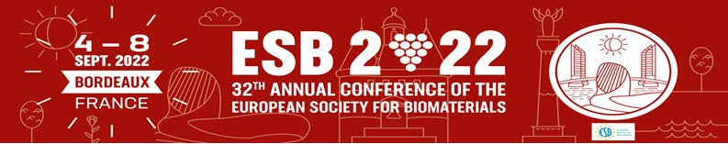

Dear Colleagues, Dear Friends

It is our pleasure to invite you to the 32nd Annual Conference of the European Society of Biomaterials which will take place from September 4 to 8, 2022 in Bordeaux, France.

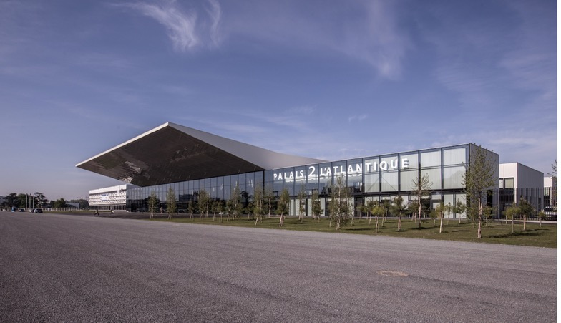

We are happy to announce that the Call for Abstracts for ESB 2022 is now open.
Abstract submission for the conference is only possible via the online submission platform: https://www.esbbordeaux2022.org/abstracts/
The online abstract system will take you step by step through the submission process.
Upon completion of the submission process you will receive a confirmation e-mail.
The abstracts should be submitted until 28 February, 2022.

We are also happy to announce that the Call for Symposia for ESB 2022 is now open:
https://www.esbbordeaux2022.org/index.php?onglet=22
Proposals should be submitted until 31 January, 2022, using the template that can be downloaded on the website.

Registration to ESB 2022 will start online on 10 December, 2022 via the online platform. All information for early bird and late fee, regular full congress registration, student full congress registration and One-day registration will be indicated on the website: www.esbbordeaux2022.org/

Please do not hesitate to contact the conference secretary for more information or any further questions: contact@esbbordeaux2022.org

Kind regards,

The National Organizing Committee.

